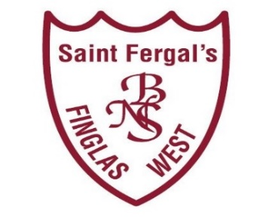
Application Form: St Fergal’s BNS – Roll No.: 18137D
Registration Date: | __________________________
Office: 01 834 7609 / 086 189 5783 | Home School Liaison: 086 888 7693
Email: info@stfergalsbns.ie | Website: www.stfergalsbns.ie
Pupils First Name
Pupil’s Middle Name
Pupil’s Surname
PPS Number
we cannot accept an application without a valid PPSN
Date of Birth
Gender
Address
Eircode
Contact Email Address
Parent 1/Guardian’s Name
Phone Number
Parent 2/Guardian’s Name
Phone Number
Are any siblings enrolled in this school?
Are any siblings enrolled in St Brigid’s Infant School
Are any siblings enrolled in St Brigid’s Senior Girls School
Name of Current School.
Name of emergency contact person/s
Relationship to child
Phone Number
Please remember to let us know if any of the contact names or phone numbers you have provided change.

