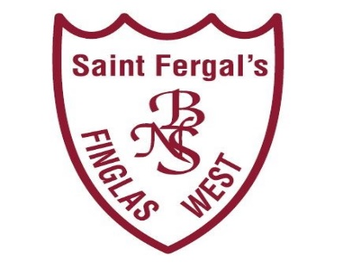

Scoil Náisiúnta Naomh Feargal
ANNUAL ADMISSION NOTICE
in respect of admissions to the 2024/2025 school year

This notice was published on 2nd October 2023

Admission Policy and Application Form
A copy of the school’s Admission Policy and the Application Form for Admission for the 2024-2025 school year is available as follows: –

To download at: www.stfergalsbns.ie
On request: By emailing info@stfergalsbns.ie or writing to: St. Fergal’s BNS, Cappagh Rd, Finglas West, Dublin 11 , D11 E925

PART 1 - Admissions to the 2024-2025 school year

Application and Decision Dates for admission to 2024-2025
The following are the dates applicable for admission to Second Class

The school will commence accepting applications for admission on | 02/10/2023
The school shall cease accepting applications for admission on | 13/11/2023
The date by which applicants will be notified of the decision on their application is | 04/12/2023
The period within which applicants must confirm acceptance of an offer of admission is | 2 weeks
*Failure to accept an offer within the prescribed period above may result in the offer being withdrawn

Note: the school will consider and issue decisions on late applications in accordance with the school’s admission policy.

Special Class Application and Decision Dates for admission to SN Naomh Feargal
The following are the dates applicable for admission to the school’s Special Class which caters for children with ASD -
The school will commence accepting applications for admission to the special class on | 02/10/2023
The school shall cease accepting applications for admission to the special class on | 08/03/2024
The date by which applicants will be notified of the decision on their application for admission to the special class is | 22/03/2024
The period within which applicants must confirm acceptance of an offer of admission is | 2 weeks
*Failure to accept an offer within the prescribed period above may result in the offer being withdrawn

Number of places being made available in 2024-2025

The number of places being made available in second class is | 50
The number of places being made available in the special class* catering for children with ASD is | 5 (Early Intervention)  0 (Primary ASD class)

