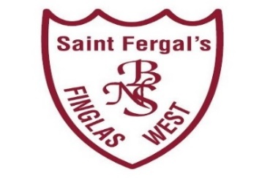
Application Form to Special Class for children with Autism
St Fergal’s BNS – Roll No.: 18137D
Registration Date: ____________________________________
Office: 01 834 7609/ 086 189 5783 | Home School Liaison: 086 888 7693
Email: info@stfergalsbns.ie | Website: www.stfergalsbns.ie
Pupils First Name
Pupil’s Middle Name
Pupil’s Surname
PPS Number (we cannot accept an application without a valid PPSN)
Date of Birth
Gender
Address
Eircode
Contact Email Address
Parent 1/Guardian’s Name
Phone Number
Parent 2/ Guardian’s Name
Phone Number
Are any siblings enrolled in this school ? | Yes |  |  | No
Does your child have a confirmed diagnosis of ASD ? | Yes |  |  | No
Does your child have a written recommendation from a | Yes |  |  | No
certified psychologist for an ASD-Specific special class?
Does your child currently have any siblings enrolled in St | Yes |  |  | No
Brigid’s Infant School or St Brigids’s Senior Girls School ?
Name of Current School
Name of Emergency contact person/s
Relationship to child
Phone Number
Please remember to let us know if any of the contact names or phone numbers you have provided change.

